8-1 Recitation Activity

1. In each of the following, find all point(s) (x, y) (if any) that make each equation true:
2. S-Z p. 549:  and 
3. S-Z p. 549: S-Z p. 549:  and 
4. S-Z p. 549;  and 
5. S-Z p. 549:  and 
6. S-Z p. 549: and and 
7. Explain why the elimination method works. You may use the system in #1a as an example. ***Hint***: Assume that you are only dealing with the point (x, y) that makes each equation true. What is 3x + 4y the same as? What is -3x – y the same as. Are we really “adding equations” when we “add”?
8. Explain why the substitution method works. You may use the system in #1a as an example (solve for y in the second equation first). What are you assuming about (x, y) when you “plug in” -3x – 5 in for y in equation #1?
9. In each of the following, find all point(s) (x, y, z) (if any) that make each equation true:
10. S-Z p. 557: 
11. S-Z p. 557: 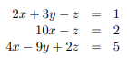
12. S-Z p. 557: 
13. S-Z p. 553: explain what this picture illustrates about a 3 by 3 system:

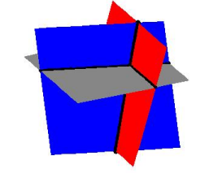

1. Write a system of linear equations with (-4, 11) as its only solution.
2. Write a system of linear equations with both (-4, 11) and (3, 7) as solutions.
3. Calc-Medic 6.1 #3: Ms. Stecher starts a T-shirt company with Ms. Gallas. The startup cost was $1200 for equipment and supplies. It costs them $5.50 to make each shirt. They will charge $9 per shirt.
   1. Write an equation to represent the cost of producing *x* t-shirts.
   2. Write an equation to represent the revenue of producing and selling *x* t-shirts.
   3. How many shirts do they need to sell to break even? How many shirts do they need to sell to make a profit of $150?
4. Calc-Medic 6.2: . Fitness Frenzy charges $10 per month and a $59 startup fee. Lean Machine Gym charges $15 a month and a one-time membership fee of $34. After how many months would the amount of money paid at each gym be the same? How much would be paid?
5. Calc-Medic 6.2: Ashmita went to a restaurant and spent three times as much on her entrée as she did on her dessert. After adding the 6% sales tax, her total came to $18.23. Which system of equations could be used to find *e,* the cost of her entrée, and *d*, the cost of her dessert?
$\left\{\begin{aligned}3e=d \\ e+d+6=18.23\end{aligned}\right.$

$\left\{\begin{aligned}3e=d \\ 1.06(e+d)=18.23\end{aligned}\right.$

$\left\{\begin{aligned}3d=e \\ 1.06(e+d)=18.23\end{aligned}\right.$

$\left\{\begin{aligned}3d=e \\ e+d=18.23-.06\end{aligned}\right.$

6. Calc-Medic 6.3: Panera Bread is known for their delicious bagels, a popular choice for breakfast or a mid-afternoon snack. It’s also a beloved item to bring to work. Peyton, Kelly, Carter, and Cecily take turns bringing food for their department each Friday.
   1. Peyton’s Panera Bread order is shown below. What is a *possible* cost for a single bagel and what is a *possible* cost for one tub of cream cheese? Explain your thinking.

* 1. Kelly bought 12 Cinnamon Crunch bagels and 3 tubs of plain cream cheese. If Panera charges fairly, how much should Kelly’s order cost? How do you know?

What do you think it means to charge fairly?

c. Assuming that Panera charges fairly, find the cost of a single bagel and a single tub of plain cream cheese or explain why this is not possible.

1. Graphical user interface

   Description automatically generated(Continued from #11). Calc-Medic 6.3: Carter loves Panera, so when it was his turn to bring food he ordered more Cinnamon Crunch bagels than Peyton and double the amount of cream cheese. His order is shown.

1. How does Carter’s subtotal compare to Peyton’s?
2. Can you figure out the cost of a single bagel and the cost of a single tub of cream cheese?
3. Cecily went to Panera and bought 7 bagels, 1 tub of cream cheese, and a salad. Her subtotal (before tax) was $23.71. Find the cost of her salad.
4. C-Medic 6.3 Find the value of the constant *k* so that the system has infinitely many solutions.
$$\left\{\begin{aligned}-10x-5y=-2 \\ 22x+11y=k\end{aligned}\right.$$

5. Calc-Medic 6.3 (Multiple Choice) An independentlinear system will always include two lines with
6. Same slope and same y-intercept
7. Same slope and different y-intercept
8. Different slope
9. Different slope AND different y-intercept
10. Calc-Medic Linear equations in 3 variables ($x, y,$ and $z$) represent planes instead of lines. Look at the five scenarios below and determine which systems are *independent,* which systems are *dependent*, and which systems are *inconsistent.* How do you know?

1. Calc-Medic At a grocery store, a tub of ice cream is on sale for $1.12 less than the regular price. The cost of 5 tubs at regular price is the same as the cost of 7 tubs at sale price. Let *r* be the regular price of a tub of ice cream and *s* be the sale price of a tub of ice cream. Write a system of equations that can be used to find the values of variables *r* and *s*. Then find *r* and *s*.
2. Calc-Medic: Is $(3,-1, -2)$ a solution to the system given below? Give a reason for your answer.
$$\left\{\begin{aligned}x-3y+2z=2 \\ 5x+y-z=16 \\ -4x-2y+3z=-20\end{aligned}\right.$$

3. Calc-Medic; Last Friday, Tommy’s Car Wash provided car washes to 243 customers. Daily earnings totaled $2,064.  Customers can choose from three different washes: “Quality” costs $6, “Super” costs $9 and “The Works” costs $15. Three times as many people buy the “Quality” wash as “The Works”. How many of each kind of car wash were sold?
4. MFG 8.1: 8.4

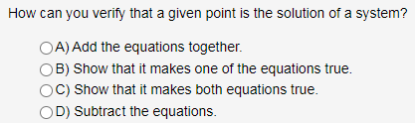

MFG: 8.1 8.23: The mathematics department has $40,000 to set up a new computer lab. The department will need one printer for every four terminals it purchases. If a printer costs $560 and a terminal costs $1520, how many of each should the department buy?

1. MFG 8.6: What do the points on the graph of an equation represent?

MFG 8.12: When is the substitution method easier to use than the elimination method. Why?

MFG 8.11: 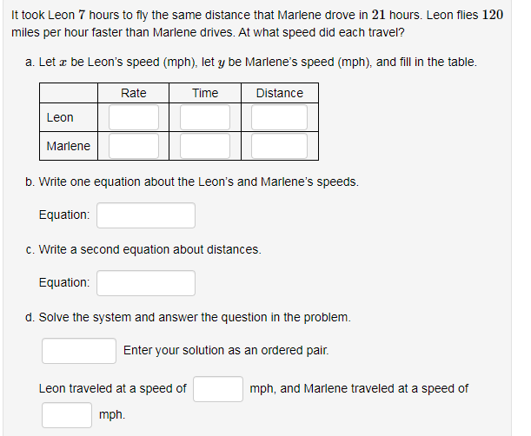

MFG 8.22:

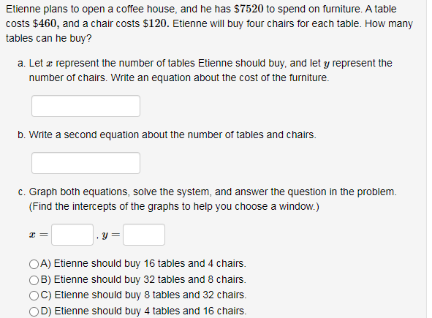

MFG 8.1 HW #30: Thelma and Louise start together and drive in the same direction, Thelma driving twice as fast as Louise. At the end of 3 hours, they are 96 miles apart. How fast is each traveling?

ORCCA 4.1 p. I-261: A college has a north campus and a south campus. The north campus has 18,000 students, and the south campus has 4,000 students. In the past five years, the north campus lost 4,000 students, and the south campus gained 3,000 students. If these trends continue, in how many years would the two campuses have the same number of students? Write and solve a system of equations modeling this problem. Solve the problem graphically as well.

True or False: When a 2 x 2 system is dependent, all ordered pairs (x, y) are solutions.

ORCCA 4.2 p. 269: In 2014, the New York Times1 posted the following about the movie, “The Interview”: “The Interview” generated roughly $15 million in online sales and rentals during its first four days of availability, Sony Pictures said on Sunday. Sony did not say how much of that total represented $6 digital rentals versus $15 sales. The studio said there were about two million transactions overall. Despite Sony not saying how much of the total revenue came from sales vs. rentals, is it possible to know that from the given information?

ORCCA 4.2 p. I-276: Notah made some large purchases with his two credit cards one month and took on a total of $8,400 in debt from the two cards. He didn’t make any payments the first month, so the two credit card debts each started to accrue interest. That month, his Visa card charged 2% interest and his Mastercard charged 2.5% interest. Because of this, Notah’s total debt grew by $178. How much money did Notah charge to each card?

ORCCA 4.2 p. 278: Desi owns a coffee shop and they want to mix two different types of coffee beans to make a blend that sells for $12.50 per pound. They have some coffee beans from Columbia that sell for $9.00 per pound and some coffee beans from Honduras that sell for $14.00 per pound. How many pounds of each should they mix to make 30 pounds of the blend?

ORCCA 4.2 HW #65 p. I-284: A test has 25 problems, which are worth a total of 100 points. There are two types of problems in the test. Each multiple-choice problem is worth 3 points, and each short-answer problem is worth 8 points. Write and solve a system equation to answer the following questions. This test has ? multiple-choice problems and ? short-answer problems.

ORCCA 4.2 HW #72. P. I-285: Renee invested a total of $9,000 in two accounts. One account pays 3% interest annually; the other pays 6% interest annually. At the end of the year, Renee earned the same amount of interest from both accounts. How much money did Renee invest in each account?

ORCCA 4.3 HW#50 p. I-299; Find the value of b so that the system of equations has an infinite number of solutions: −16x + 28y = −4 and 4x − by = 1